C++ language

* C++ is a general-purpose programming language. It has imperative, object-oriented and generic programming features, while also providing facilities for low-level memory manipulation.
* It was designed with a bias toward system programming and embedded, resource- constrained and large systems, with performance, efficiency and flexibility of use as its design highlights.
* C++ has also been found useful in many other contexts, with key strengths being software infrastructure and resource-constrained applications, including [desktop applications](https://en.wikipedia.org/wiki/Application_software), servers (e.g. [e-commerce](https://en.wikipedia.org/wiki/E-commerce), [web search](https://en.wikipedia.org/wiki/Web_search_engine) or [SQL](https://en.wikipedia.org/wiki/SQL) servers), and performance-critical applications (e.g. [telephone switches](https://en.wikipedia.org/wiki/Telephone_switches) or [space probes](https://en.wikipedia.org/wiki/Space_probes)).
* C++ is a [compiled](https://en.wikipedia.org/wiki/Compiled_language) language, with implementations of it available on many platforms and provided by various organizations, including the [FSF](https://en.wikipedia.org/wiki/GNU_Compiler_Collection), [LLVM](https://en.wikipedia.org/wiki/Clang), [Microsoft](https://en.wikipedia.org/wiki/Visual_C%2B%2B), [Intel](https://en.wikipedia.org/wiki/Intel_C%2B%2B_Compiler) and [IBM](https://en.wikipedia.org/wiki/IBM_XL_C%2B%2B).
* C++ is standardized by the [International Organization for Standardization](https://en.wikipedia.org/wiki/International_Organization_for_Standardization) (ISO), with the latest (and current) standard version ratified and published by ISO in December 2014 as [*ISO/IEC 14882*](https://en.wikipedia.org/wiki/C%2B%2B#Standardization)*:2014* (informally known as [C++14](https://en.wikipedia.org/wiki/C%2B%2B14)).
* The C++ programming language was initially standardized in 1998 as *ISO/IEC 14882:1998*, which was then amended by the C++03, *ISO/IEC 14882:2003*, standard. The current C++14 standard supersedes these and [C++11](https://en.wikipedia.org/wiki/C%2B%2B11), with [new features](https://en.wikipedia.org/wiki/C%2B%2B14) and an enlarged [standard library](https://en.wikipedia.org/wiki/C%2B%2B#Standard_library). Before the initial standardization in 1998, C++ was developed by [Bjarne Stroustrup](https://en.wikipedia.org/wiki/Bjarne_Stroustrup) at [Bell Labs](https://en.wikipedia.org/wiki/Bell_Labs) since 1979, as an extension of the [C language](https://en.wikipedia.org/wiki/C_%28programming_language%29) as he wanted an efficient and flexible language similar to C, which also provided high-level features for program organization.
* Many other programming languages have been influenced by C++, including [C#](https://en.wikipedia.org/wiki/C_Sharp_%28programming_language%29), [Java](https://en.wikipedia.org/wiki/Java_%28programming_language%29), and newer versions of C (after 1998).

**C++ Code use in project**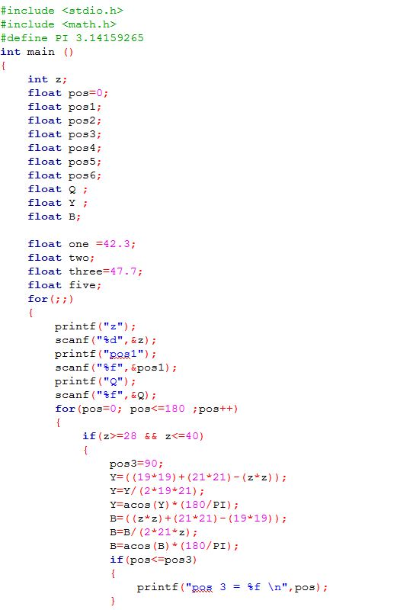

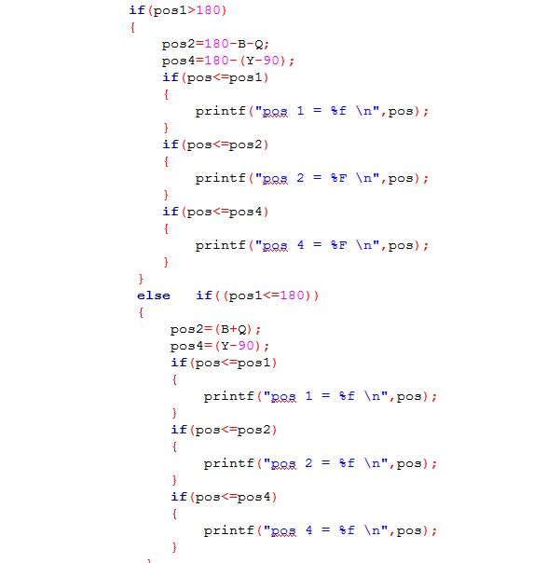

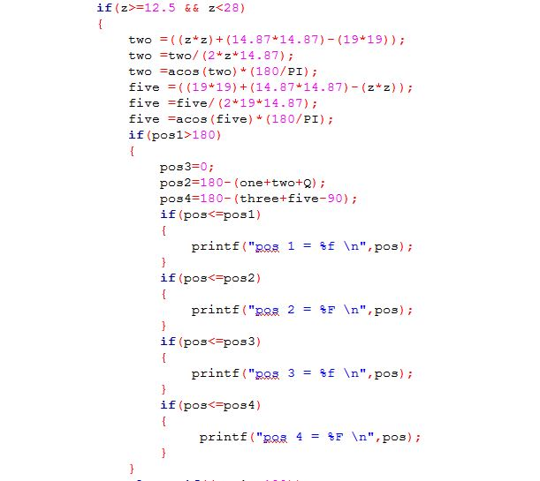

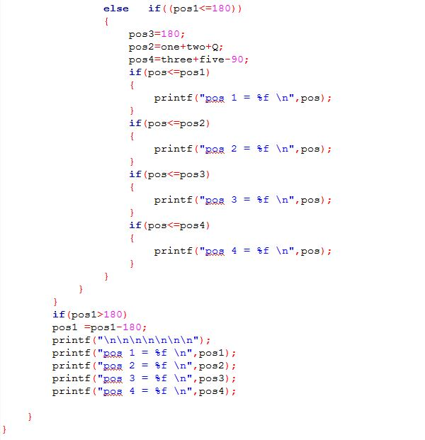

Explanation of the code:

* **First we use for loop to move all servo motor at the same time.**
* **Then we use if statement for two cases.**
* Case one :
  + - If the distance between the center of robot and the object we want from 28cm and

40 cm .

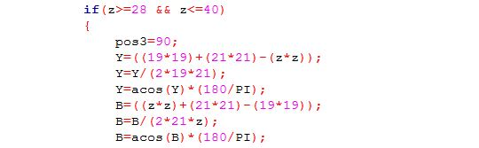

* In this case we have to state:

1. First state when the angle of first motor more than 180 degree.



1. Second state when the angle of first motor less than 180 degree.



* Case two:
  + - If the distance between the center of robot and the object we want from 12.5 cm and 28 cm .

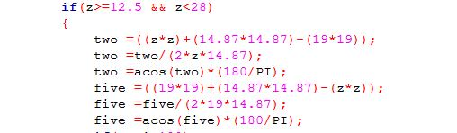

* In this case we have to state:

1. First state when the angle of first motor more than 180 degree.

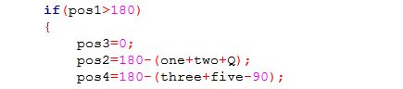

1. Second state when the angle of first motor less than 180 degree

